**Conversation Guide: Digital Health Modernization Discovery Research**

**Bold text identify the moderator’s questions.**

*Text in italics are Jen’s observations and interpretations of the participant.*

[Text in brackets are interpretations in participants’ direct quote.]

**Background (5 minutes)**

To get started, I’d like to get a little background information about you, and your experience with the VA.

1. **Can you tell me a little bit about yourself?**   
   I am retired from the Army, 24 years, 100 percent disabled veteran.

I use the Providence VA healthcare system.

I have Tricare.

I was a former Veterans service rep, but I am medically retired from there.

Now I am just a bum. *Laughs*. Unemployed, I had a business too but I sold it.

I put my years of employment in and now I just take care of my health.

**Tell me about the Veterans service work:** I worked on what they call the predetermination team. You know when the claims for pension or compensation come in and I would work those claims.

Then I ended up working for the outreach section so I worked there just before I retired.

I worked at the Providence VA taking claims and giving benefit information to veterans with the special population clinic. I was the only one that would go to the hospital twice a week.

Special outreach was the homeless clinic at the VA. It was called the special population clinic.

**Your job was to let individuals know about any and all benefits:** Yes and state benefits so we would help them.

And coordinate with the hospital if they had issues that they brought to our attention we worked close with the hospital.

1. **What year retired from Army?**

I will never forget. June 1st, 2005.

**How did you hear about VA benefits:**

I heard about it at Fort Campbell KY, when I was out processing. They had a VFW rep there when we were doing retirement physicals and stuff.

1. **What VA benefits do you receive:**

I get everything. Prescriptions, I’ve gotten some equipment, I get oxygen from them.

Like I use to tell guys I can say from the Providence VA center. All of the dealings I have had with them are the best.

I use to tell people the secret is if you think something could make your life better or help you to ask for it. And 90% of the time I would say the Providence medical center would help to get them what they needed.

No complaints, they were happy customers.

**100 percent disabled:**

Yes I am 100 percent service connected. And I’m on Social Security disability. Thats why I’m not with the VA anymore.

I retired from the VA regional office in 2013.

**After you retired you applied for SSDI:**

Yes.

**Do you remember when you applied for VA disability:**

Yes it was at Fort Campbell when we did our retirement physicals.

**When did you apply for healthcare:**

Probably in 2005 when I first retired from the military I started using it.

1. **Do you have any family members who you claim as dependents?**

I have a wife. Yes.

**On disability compensation as well:**

Yes.

**4.a. Does she receive any benefits from the VA?**

No. None at all.

1. **Do you manage any of your VA benefits online?**

I don’t use the portal, ebenefits. I don’t use that.

**The portal is ebenefits:**

Yes. If I need an award letter or some documents then I know how to login I have a username and password so I can get into that.

1. **What about health needs:**

Yes, I use myhealthevet.

I use that to renew my prescriptions, I have used the blue button to download notes, reports like if I had an MRI or anything like that and labs. So I use that.

**6.a Do you use any mobile apps to manage your health?**

No

**Mental model of health at the VA (20 minutes)**

Now I’d like to hear about your experience transitioning from the military to the VA. **(10 minutes)**

1. **How did you learn about the health care available to you through the VA, and what was the process of applying for and accessing those benefits?**

I am trying to think about to my first appointment with my primary care. My primary care was pretty helpful. They know my medical history and needs. They were pretty helpful.

**How did they learn your history:**

I think because I filed a claim that it probably going through C&P exams. Some of the information was most likely available to the hospital through the VA notes and my initial appointment with my primary care.

**After you filed the disability claim then the medical providers had access:**

Yeah. I think at the time, 15 years ago, I think I had brought a copy of my medical records for the initial visit with the primary care and talked about the disability/problems I had when I retired. What medical issues.

1. **Sounds like you applied for disability first:**

Yes

1. **Did you work with anyone to help apply:**

Yes they had a VFW rep, that was one of the stations we could go through to find out about benefits and file claim.

**What was experience like working with VFW rep:**

Actually it was pretty good, going by someone that worked at the VA. I think the VFW talked to me about my disabilities and the paperwork. They did a pretty good job.

1. **Do you remember how long it took to be approved:**

I think the healthcare was even before because I was a wartime veteran so I started using it before I was awarded my percentage.

**Wartime veteran impacts healthcare access:**

Yes, I was a wartime veteran so I was eligible.

1. **Priority groups, if you describe it to a new veteran, what would you say:**

Think of the number of people that served. Not everyone can be in the same group. The government has to prioritize the health care. They triage you based on your income, when you served, and based on your disabilities.

So I’m 100% so I am in the top priority group so I get access to pretty much everything.

Like 50 percent you have to pay co-pays but over 50 percent you don’t have to.

I would say you could have to pay a co-pay not that you will.

It is basically triage and a financial type of thing.

1. **When first applied, did you have your wife as a dependent or added later on:**

I had another wife then, I am a three timer. My second wife was married to me during service.

**How did you update your wife:**

It is simple it is VA Form 21-686C. I use to always tell guys they wouldn’t come with their marriage certificate, I told them to send a copy.

**Is it not required:**

I think the system ties in now because of the SSN. I think it pretty much ties in.

I stopped doing stuff because of COVID I use to volunteer to help with claims with DAV [Disabled American Veterans] at the hospital.

I always say it doesn’t hurt to send the information; I use to work there. It is better to have it then to have to ask for it. Always follow up with backup paperwork so it doesn’t slow it down.

1. **Have you done it online:**

Yeah I didn’t do it online. But I understand you can.

1. **Have you used any other VA services or benefits:**

The only compliant I have on the hospital side is the dental.

As a 100 percent veteran you are supposed to be entitled to dental, but if you try to get an appointment forget about it.

If you get dentures it takes 6-7 months to get them after take your teeth out.

I haven’t used it. I have gone for appointments and in the process. I paid myself and said forget it even while being a former employee knowing how to navigate the system. It’s frustrating.

I have a friend right now, he’s fed up with it and getting his own dental insurance.

The whole system itself that is the worst thing that anyone that is entitled to it has to deal with.

1. **Hard to get an appointment for dental, how about other VA appointments:**

I have never had an issue with other appointment. I have never had an issue with tests before I got off I still keep a day reminder because that’s how good and fast the appointments came up in Providence.

1. **You also have Tricare:**

Yes, because I am a retiree.

**Differences between healthcare you get from Tricare and the VA:**

I had surgery on the outside so I have Medicare. So I had the outside to do the surgery because the VA doesn’t do they type of surgery. So I used my Medicare and Tricare so it didn’t cost me anything.

Everything else I use the VA.

**Does it include things like primary care, annual checkups:** Yes I use va totally.

**Medicare and Tricare, difference:**

Because I am military retired I can keep Tricare and pay for it.

So my wife has Tricare so I pay for hers.

Now I don’t pay for mine because I have Medicare and I’m 65. What happens is I don’t have to pay for Tricare anymore because Medicare pays primary and Tricare secondary. So I can still use the outside doctors and still not pay anything.

**Outside meaning not a VA:**

Correct and with Tricare I can use for prescriptions but then have to pay co-pays whereas with the VA I don’t have to pay anything.

**Wife through your Tricare:**

Yes, she has Tricare and Blue Cross because she’s still employed.

If they [Blue Cross] pay 80 percent then Tricare pays the other 20 percent.

And Tricare is only like $300 and change a year for secondary healthcare so it is cheap to pick up.

1. **For outside care, do you use something similar to My HealtheVet:**

No. On Myhealthevet you can input health data. I don’t do that but usually.

I had surgery for weight reduction, a gastric sleeve because I wanted to lose some weight. I brought it to my primary care [at VA] and she input the data into the VA hospital system.

**Records taken to the next appointment with VA:**

Yeah. Only because I didn’t want to input them myself. I know you can do it yourself on My HealtheVet.

**Would it have been the same if you added it yourself:**

Probably yeah, I would think that once it is in the system it is there if they pull your file. If they know how to look into it, it would be there because it wouldn’t be under the regular notes.

I don’t know how that would work for the hospital folks.

1. **How would you describe a “disability percentage” to a new Veteran?**

I would show them the charts because that’s what they understand - the money.

Then explain think of your body as 100 percent because after they get the percentage, doing the VA math they don’t understand the VA math.

It works on the whole body, the percentage, and if you have 5 things that are 10 percent each they think it is 50 but it might not be 50, it might be 30.

There is a formula that the bean counters use and the raters.

If you lose an arm and they give you 80 percent for the loss of the arm, you lost your fingers so you can’t claim those.

Veterans don’t really ask that until they get it, but each case is different so you have to sit down and explain how the VA came to that conclusion. Without going into the regulations and showing them what it’s base don.

**They may not know to ask that question before rating:**

Correct. Like they would say why do I only have 30 percent for my knee.

Sometimes I would show them how it is broken down for 10 percent here and 20 percent here’s the additional things but I would have to show them in the regulation.

1. **In your mind, is there a relationship between “disability” and “health care”?**

Nah, as a matter of fact they are pretty fair with everyone.

From working at the hospital I have seen guys get the scooters that aren’t combat veterans and without the service connection but they still get it.

I don’t think that the hospital really looks at it like you have to be 100 percent other than dental.

On the whole I think the care that is received, I don’t personally think the staff anyways looks at you any differently.

They have different regulations as to what you are entitled. But as far as the care itself I don’t think there is anything.

**Outside of preferential treatment, does your disability impact your healthcare coverage, like types of things you can get from the VA:**

Oh yeah. Like I said I am 100 percent so I get dental and pretty much anything I need.

I know as far as, I’ll give you a for instance. There’s a clothing allowance you can get if you have a brace or prosthetics. Wearing your pants or slacks out because of rubbing, those types of things yes.

They have to look at the rules for everything like if they are 60 percent and wants dental can’t to use it.

So and so wants to file for special adaptable house there are rules and things you have to do for it or special adapted automobile.

As far as the treatment itself I don’t think the staff looks at you and says they will give you better treatment because you have a higher rating other then they have to go by the regulations.

1. **When it comes to your health care, what is the most important thing you need from the VA?**

Communication. And feedback on tests and stuff.

If you have an MRI or being treated for something you want the information. I have liver issues when I go for a test or do scans, getting the feedback. Because you are wondering about it.

**What do you mean feedback:**

Results.

That’s where HealtheVet come in because you can read the notes and even the CAT scan stuff and at least you can get an idea.

**To check notes, is that something you do in myhealthevet:**

Yes, I do that.

Sometimes they aren’t there. My last liver test, I never seen the lab stuff and I Googled and got nervous but I misinterpreted what the readings were. You have to be careful. *Participant laughs.*

Now I’d like to ask you how you manage information and tasks related to your health care. For each one, talk me through the steps you’d take. If there is something that you go online to complete, I may ask you to share your screen so I can see what you would do. **(10 minutes)**

**Tasks** Moderator should prompt about device usage if participant mentions digital tools or resources.

* **How would you reach out to your VA care team if you had a question?**

I would call the 737100 number and ask to have my primary care call me or whoever it is if it is a specialty clinic I would call them.

I recently got a new primary care so I had a telephone appointment with her and she said I can use my HealtheVet to send messages. I have never done that.

* **Telephone appointment, video, or phone:**

No it was just a telephone call.

It was the first time that I even talked to who would be my primary care. That was a scheduled appointment.

* **Number memorized, your experience getting care or as an employee:**

At one time I used to renew my prescription on the telephone.

* **How would you refill a prescription you have with the VA?**

I do that on myhealthevet because the prescriptions are listed. Very simple.

Once you are online you go to refill prescription and they all come up. If it is refillable you click check and submit.

If it were expired and didn’t know and primary care hasn’t seen you since it expired I would call the 7100 number and leave a message for it to be refilled.

I had never even talked to the doctor I do that with the triage nurse when I asked for primary care and they ask your name.

I had success with that no problem.

With myhealthevet it is so simple to just go in.

All of my prescriptions tell you how many refills you have and they ship it to your house. It’s a good system. Real good.

* **Can you show me how you refill it on myhealthevet:**

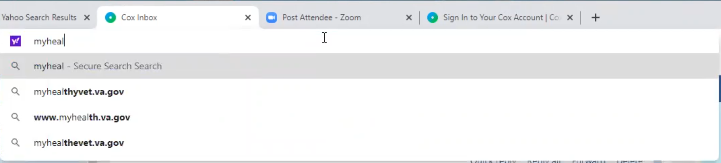

*Participant searches for myhealthyvet in browser address bar.*

I might have to change my password so.

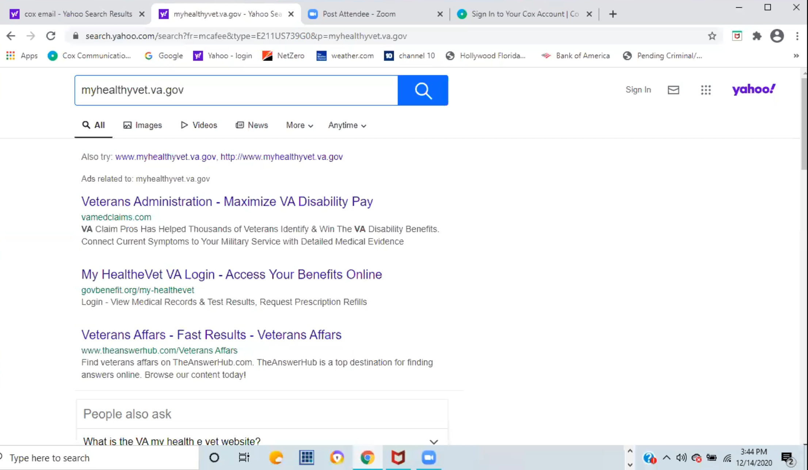

*Participants search results for [myhealthyvet.va.gov](http://myhealthyvet.va.gov).*

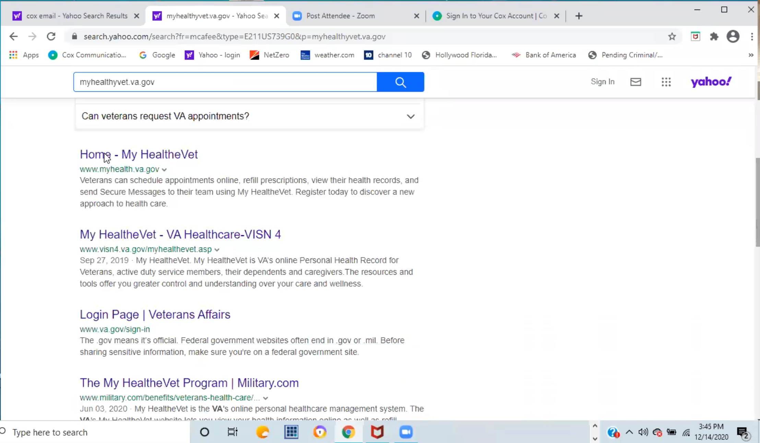

*Participant has to scroll down to find correct website in search results.*

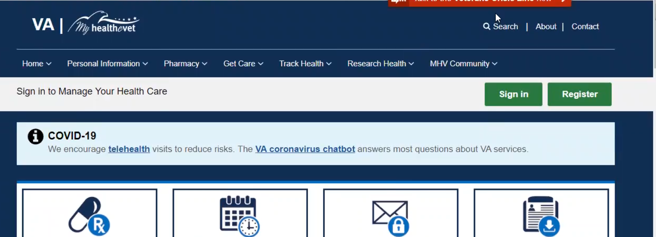

*Participant clicks on green “Sign in” button in upper right of page.*

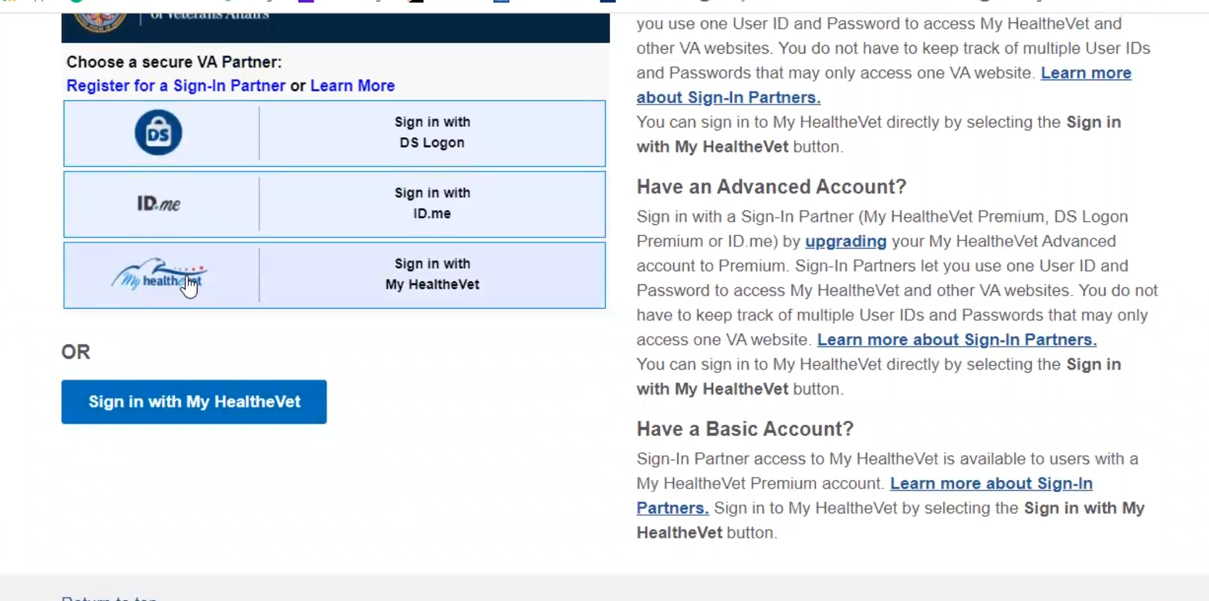

*Participant clicks on secure VA Partner My HealtheVet login.*

* **How do you know which to sign in with:**

Yeah because, I don’t have a card. I’d have to go back and look again, but it’s simple it is myhealthevet password.

I will just say I forgot my password it is so simple to navigate.

*Participant submits from to password.*

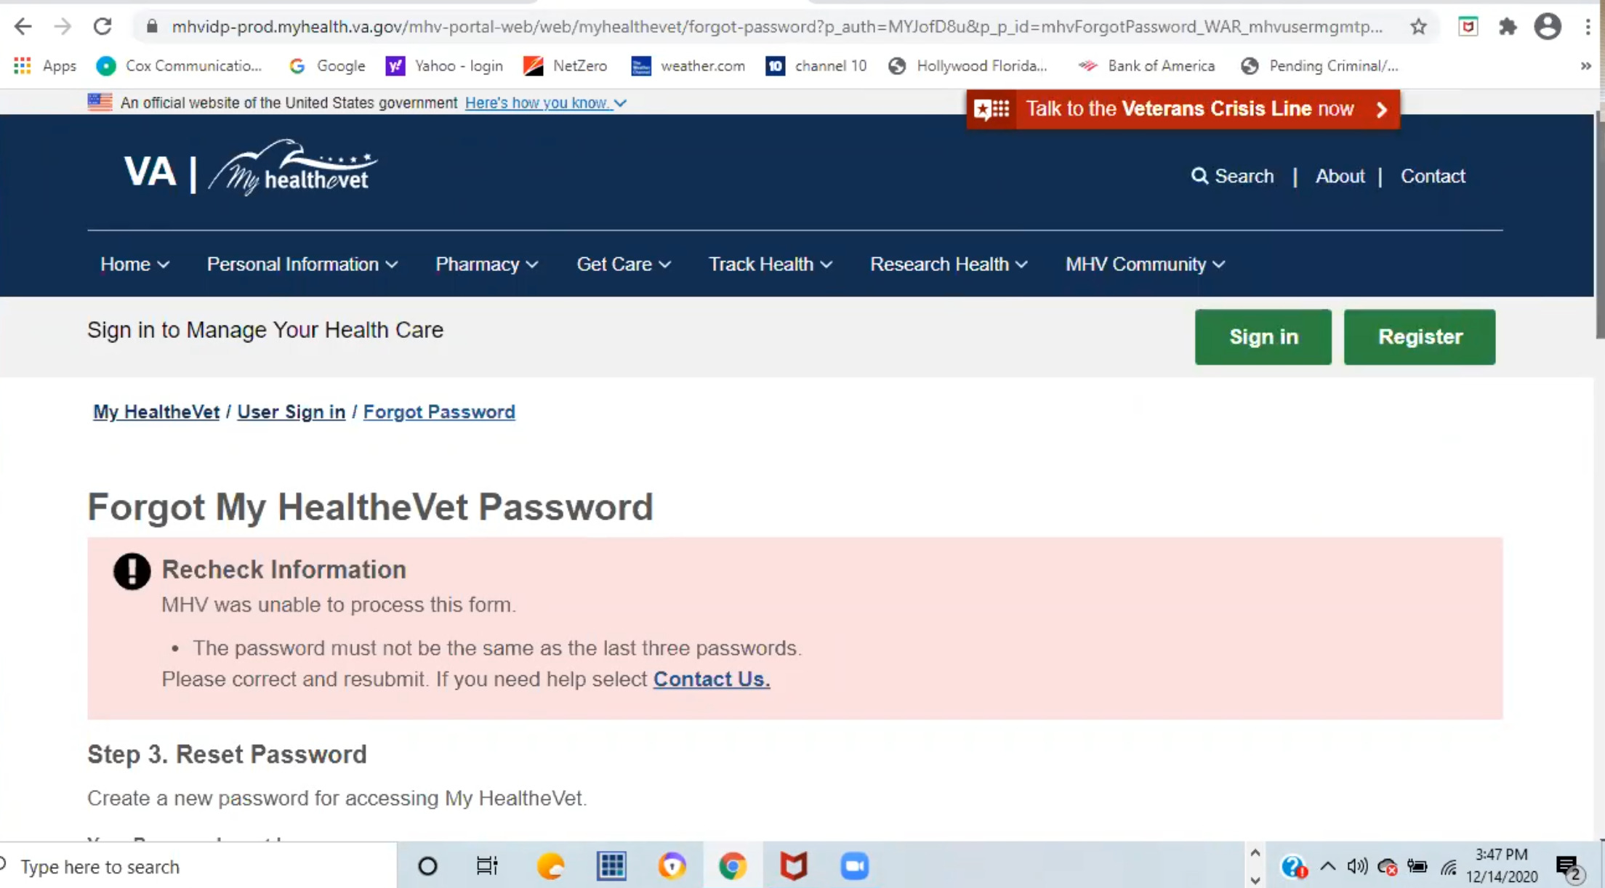

*Participant gets error message when resetting password. Figures out quickly it is because it’s a password they’ve used recently.*

*Participant enters in new password, successfully resets it, and signs in.*

Okay I am in Emily. You want to see prescriptions refill?

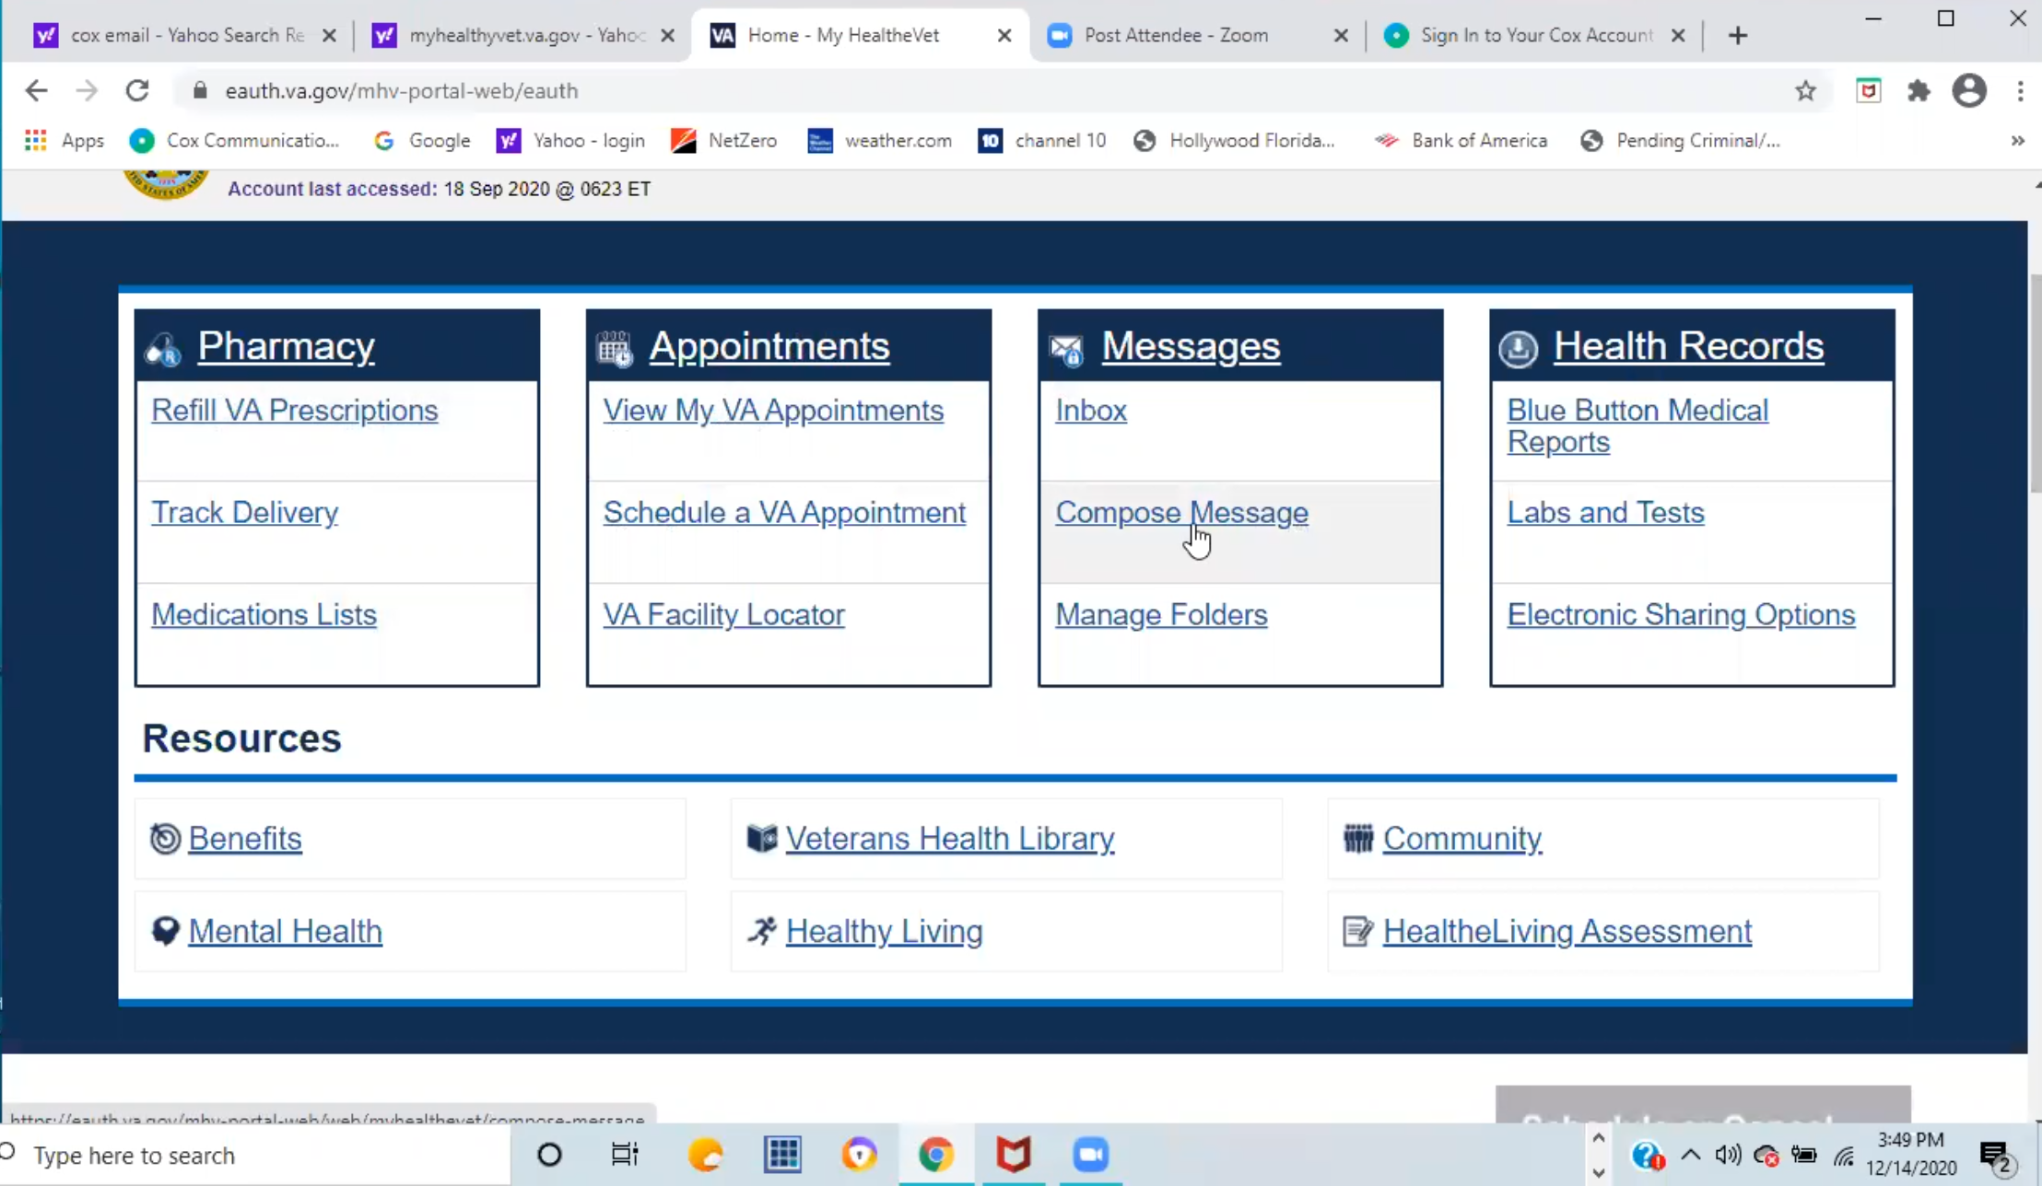

*Participant hovers over and talks about different links on home page.*

See pharmacy, appointments, messages you can compose messages as well.

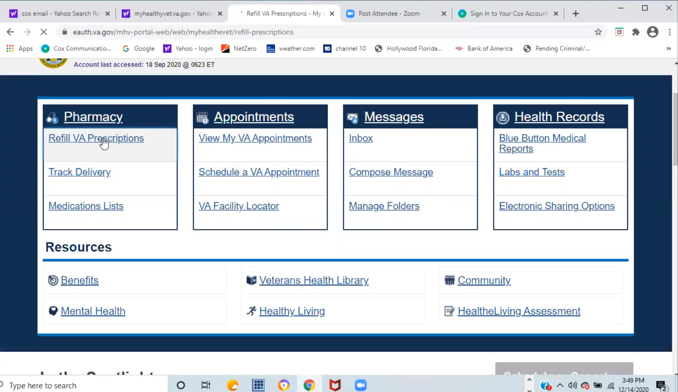

*Participant clicks on Refill VA Prescriptions link.*

SO refill prescriptions, then it shows you them.

I am going to refill these anyways so you click the ones that need to be refilled. It is good I came on today.

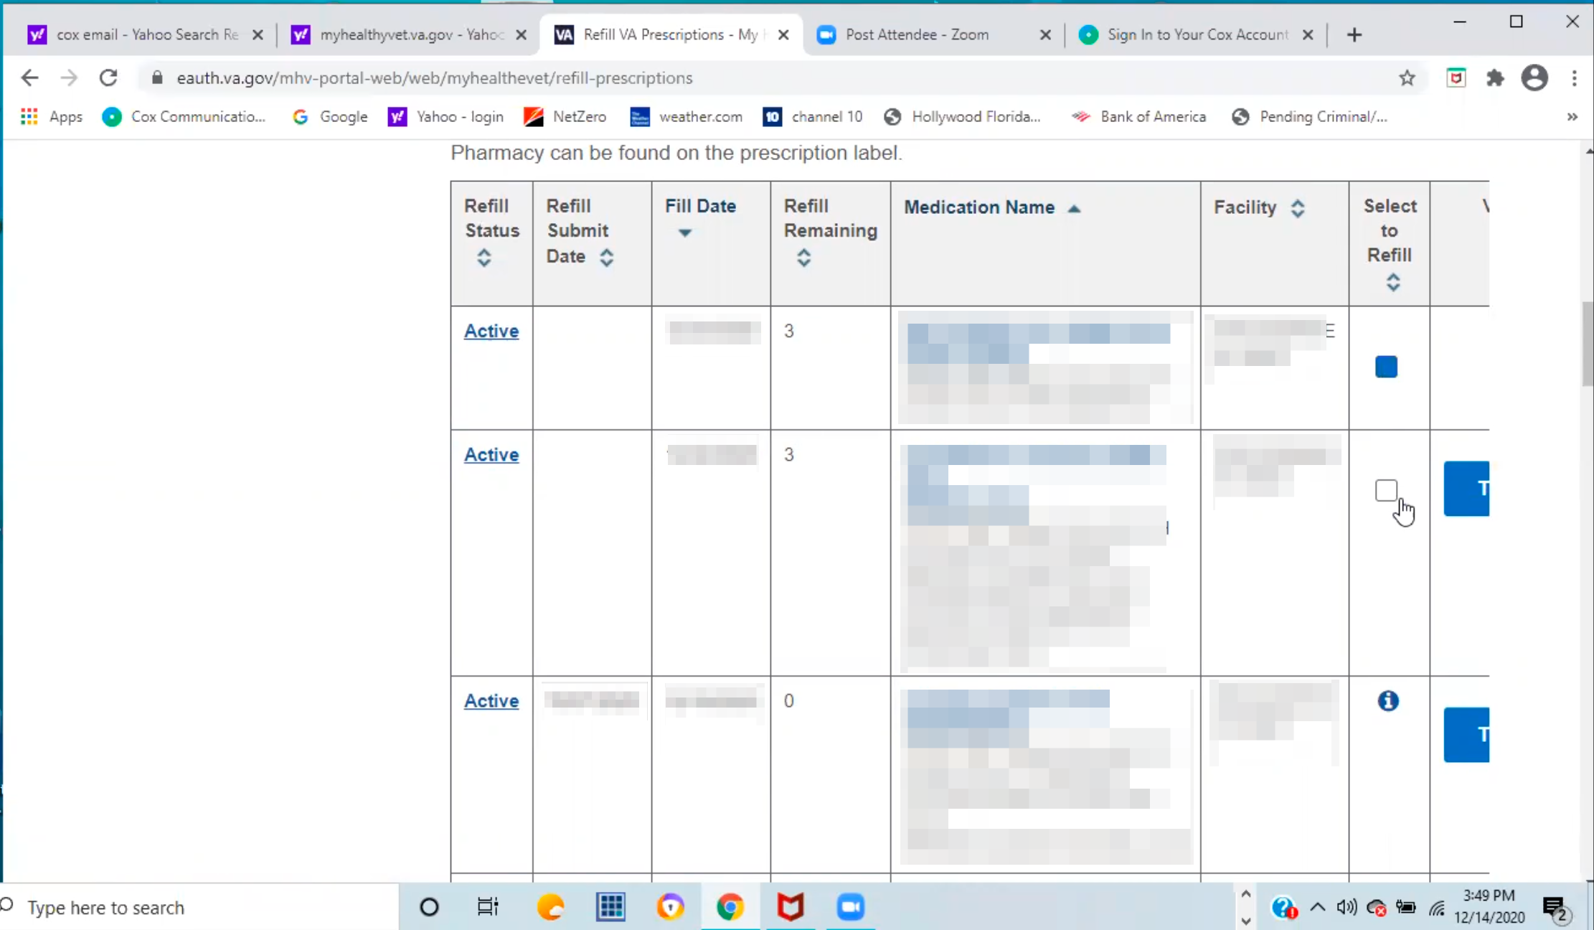

*Participant show how to view and refill prescriptions.*

Then you click submit refills.

And in 7-10 days they will come to the house.

Page two, I might as well do this while I am here. *Participant refills all prescriptions.*

That’s it.

Actually you can track your prescriptions as well but I never had because I come like clock work. You can track them if you want.

You were talking about what you might do with outside doctors, you can enter medication under self-enter medication and supplements so they can see that. Like multivitamin are mine so primary care doctors can see that.

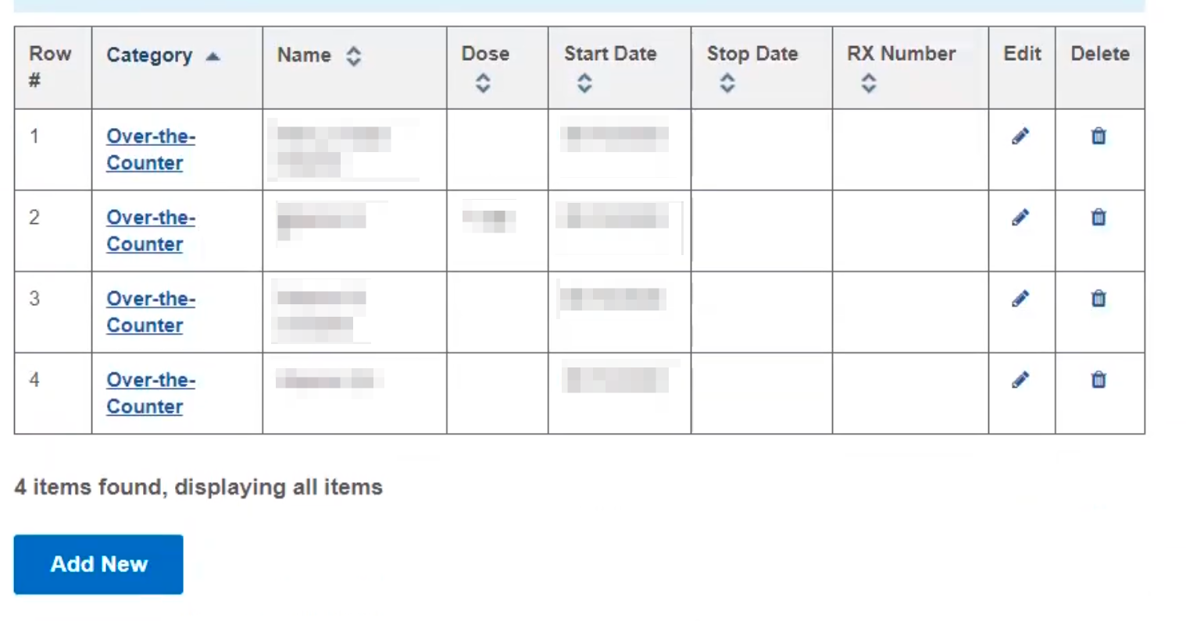

*Participant shows over the counter vitamins listed on Self-Entered Medications + Supplements page.*

Then it is over the counter. That works pretty good.

* **For self-entered, is that something you brought in to your appointment and had your provider enter:**

Yeah when I had the gastric sleeve surgery, I have to take vitamins for the rest of my life. So I brought that into the primary care.

If the VA had them in there already they would put it there but the VA doesn’t have them so I have to kick in some money.

**Branding and trust (5 minutes)**

Now I’d like to ask for your thoughts on My HealtheVet. (Confirm that participant has used My HealtheVet previously. If not, amend questions below to capture their first impressions while looking at a logged in account.)

1. **How would you describe My HealtheVet to a fellow Veteran?**

I would explain to them a big plus is refilling prescriptions you don’t have to go to the hospital to wait.

You can check how many refills you have left it is another reminder if it is a last refill so you can message the primary care to let them know you are on the last refill.

You can send a message on My HealtheVet directly to primary care to have it renewed. I haven’t used it.

It’s actual a real good site.

Even if you go back.

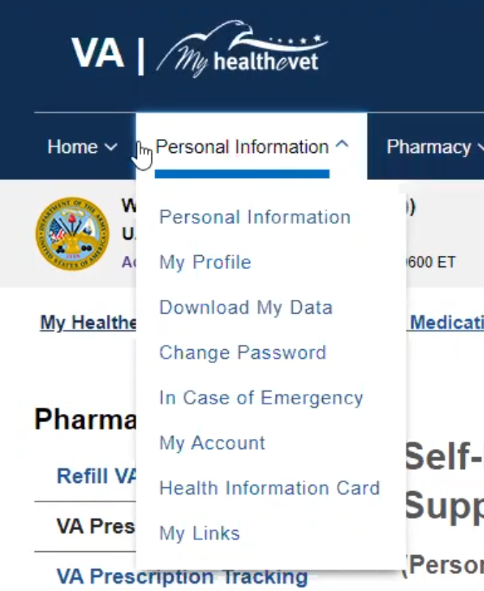

*Participant starts looking through main navigation. Abandons it quickly and clicks the Home link in main navigation.*

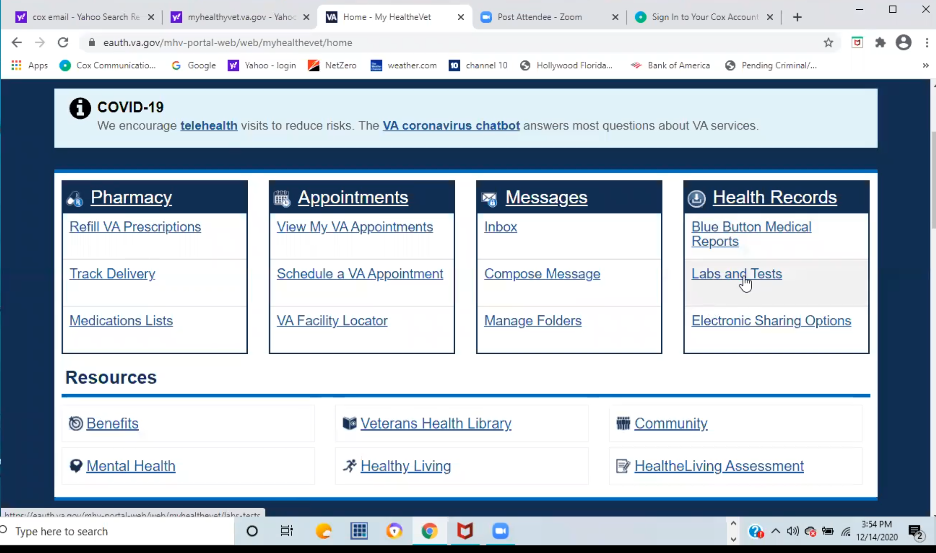

*Participant goes to Home page, hovers over while talks about about links under Health Records.*

The Blue Button is where you can get the doctors notes, labs, tests, results if you want to read that.

If you have outside providers there are ways for you to share your VA medical stuff with your primary care and I guess vice versa.

I haven’t used it before because I use the VA for everything.

1. **On a scale from 1-5, with 1 being very dissatisfied, and 5 being very satisfied, how satisfied are you with My HealtheVet:**

Oh a 5, it is a good system.

The big thing is being able to message the providers, see what they put in the notes, looking at the labs. I have never scheduled one on here but I view the appointments and put them in my dayminder.

*Interesting that participant references a lot of functionality they’ve never used when explaining why they would give it a 5 rating. Seems to be reviewing links on four “blue boxes” on home page.*

Then refilling the prescriptions are a biggie because you don’t need to go and wait for them.

I don’t know the timeline before you can refill but I have never ran out of medication and not gotten new ones in. If you look at the bottle of pills and see that you need to fill because you are done with that bottle you would already have your refill.

If the veteran can manage it, it is a good system.

1. **On a scale from 1-5, with 1 being very low, and 5 being very high, how would you rate your trust in My HealtheVet?**

5. I think it is secure, your personal information is secure. That is pretty much it.

1. **Does it feel like from your experience that all your information is all update to date and accurate:**

Yes.

Even going in and looking at the notes, I have had appointments and I wait maybe 2-3 days and I can go in and look at them depending on the backlog at the labs.

**Two days after you can see notes:**

Yeah 2-3 days.

**My HealtheVet patient portal (15 minutes)**

Let's take a look at My HealtheVet together.

Moderator will ask participant to share screen if not already, or show logged in My HealtheVet account. **(5 minutes)**

1. **What do you wish this website did that it doesn’t do right now**

Maybe a spouse’s portal.

I mean without the spouse having access, even though it is a spouse you still need approval from the veteran to disclose any information.

If someone comes in with their wife I have to ask if it is okay with them that their wife sits there while we talk.

If my HealtheVet could do a limited portal or there was a way for the veteran to give approval for someone to access their medical reports, reorder prescriptions or do whatever they need to do it would probably work well for caregivers.

Especially for the elderly veterans, or veterans with dementia, that need help from a daughter or wife. They could do it anyways but still if they don’t know about it or if the veteran is a geriatric and the people caring for them don’t know this exist they may be going to the hospital and not even really have to go because he needs to get the prescriptions. They may not know that they could go right online and have it come right to the house. They could compose a message and send it to whatever doctor.

Access to those types of people would be great.

**Thank you and closing (2 minutes)**

**Feedback or questions:**

If you want to give me a call when you’re working on stuff don’t hesitate.